Monday  28/9/26  No Spending  Outcomes  1,2,3,4,5 | Tuesday  29/9/26  No Spending  Outcomes  1,2,3,4,5 | Wednesday  30/9/26  No Spending  Outcomes  1,2,3,4,5 | Thursday  1/10/26  No Spending  Outcomes  1,2,3,4,5 | Friday  2/10/26  No Spending  Outcomes  1,2,3,4,5
Kite Making  Learn how to make kites then fly them.  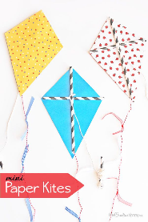  Incursion | Mexican Feast  Come try the taste of Mexico  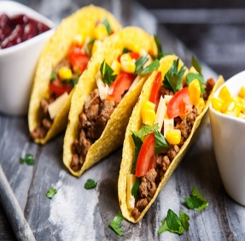  Incursion | Jam Band  St Clair  10am-11.30    Excursion | Movies  Forgotten Island  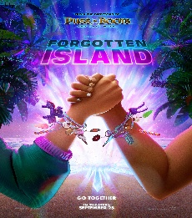  $8.00 Popcorn and drink deal  Excursion | K-POP Day  Crazy hair, Face painting and dress up as your favourite K-Pop    Pizza for Lunch  Incursion
Monday  5/10/26  No Spending  Outcomes  1,2,3,4,5 | Tuesday  6/10/26  No Spending  Outcomes  1,2,3,4,5 | Wednesday  7/10/26  No Spending  Outcomes  1,2,3,4,5 | Thursday  8/10/26  Spending  Outcomes  1,2,3,4,5 | Friday  9/10/26  No Spending  Outcomes  1,2,3,4,5
Labour Day Closed   | Interactive Games at the Program    Incursion | Bowland  10am-12pm  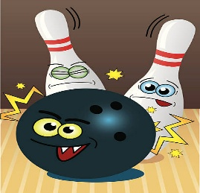  $9.00 Hot Chips Deal  Excursion | Wizbang  10am – 12.30  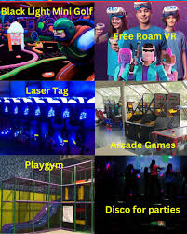  Excursion | Wheels Day  Safety gear must be worn    Sausage sizzle lunch  Incursion
BOOKINGS CANCELLATIONS ARE ESSENTIAL: Bookings are essential to determine the Staff/Child/Young people ratio. Please book your children/Young people using the booking in sheet attached for specific days excursions your family requires. Please ensure your child/ren bring recess a packed lunch, drink bottle and a hat. It’s a long day so you may want to pack a little extra. Play Café socks must be worn.

